**ThermoApp Manual**



Created for the ThermoApp

by

Luke Houben, Bas Schleijpen & Sander van de Ven

Index Page

Home page 3

Week schedule 4

Chart 5

**Home page**

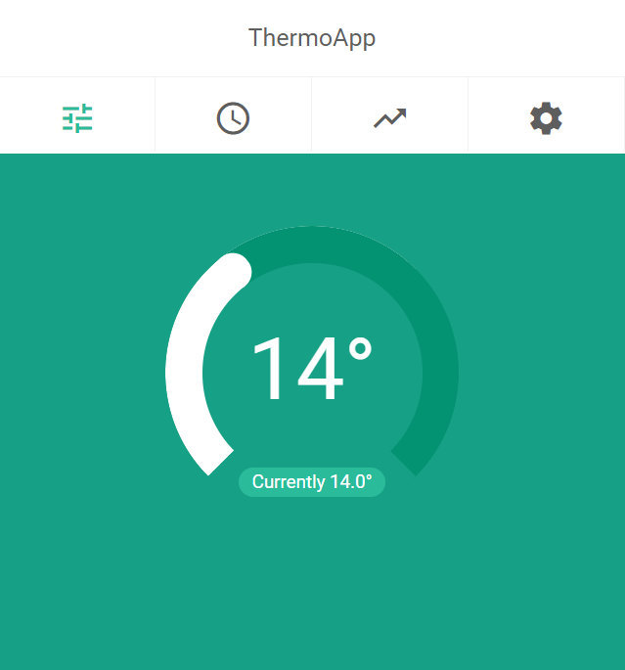

This is the homepage of the ThermoApp. At the home page the day and time are visible. Besides that in the middle of the user his or her screen a slider is visible. This slider indicates the current temperature at the located thermostat. The slider may be used to set the current temperature according to preference. This can be done by simply clicking anywhere on the curve of the slider, but it can also be done by sliding the slider along its curve. For precise .1 degree changes click on the degree number centered in the middle to change the current temperature with your keyboard.

From the homepage forward you can click on two further options in the tabs at the header:

* The clock, which indicates presets as in week schedules, temporary future changes and day and night temperatures.
* The chart arrow, which indicates a chart. This directs to a page where the costs for the past energy use of the thermostat can be seen.

**Week schedule**

**Chart**

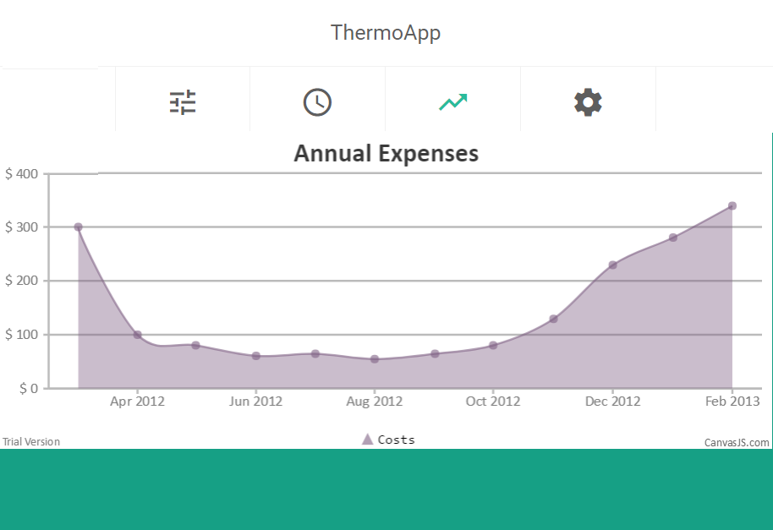

This is the chartpage. Here you can see a chart of the annual expenses for the thermostat. The graph shows the prices per month of the energy used. This makes it possible for the user to see if there are leaks, where the costs would raise unlogically high in the graph.

From the chartpage forward the user has two options:

* The user can click on the “first icon”, which brings the user back to the home page.
* The user can also click on the clock, which brings the user to the page with preset possibilities like the week schedule.